Gambia, The

## Political Stability Estimate Data

The data set shows the political stability estimate of the country each year.

## # A tibble: 19 x 5  
## country iso3c date stability stabilityCategory4   
## <chr> <chr> <dbl> <dbl> <chr>   
## 1 Gambia, The GMB 1996 0.559 moderately stable   
## 2 Gambia, The GMB 1998 0.676 moderately stable   
## 3 Gambia, The GMB 2000 0.533 moderately stable   
## 4 Gambia, The GMB 2002 0.826 moderately stable   
## 5 Gambia, The GMB 2003 0.324 moderately stable   
## 6 Gambia, The GMB 2004 0.166 moderately stable   
## 7 Gambia, The GMB 2005 0.202 moderately stable   
## 8 Gambia, The GMB 2006 -0.0343 moderately unstable  
## 9 Gambia, The GMB 2007 0.0478 moderately stable   
## 10 Gambia, The GMB 2008 0.0651 moderately stable   
## 11 Gambia, The GMB 2009 0.124 moderately stable   
## 12 Gambia, The GMB 2010 0.0654 moderately stable   
## 13 Gambia, The GMB 2011 -0.000271 moderately unstable  
## 14 Gambia, The GMB 2012 -0.000779 moderately unstable  
## 15 Gambia, The GMB 2013 -0.0486 moderately unstable  
## 16 Gambia, The GMB 2014 -0.151 moderately unstable  
## 17 Gambia, The GMB 2015 0.0196 moderately stable   
## 18 Gambia, The GMB 2016 -0.434 moderately unstable  
## 19 Gambia, The GMB 2017 -0.208 moderately unstable

## Political Stability Estimate Plot

The plot shows the trends of stabilization and destabilization for the each country.

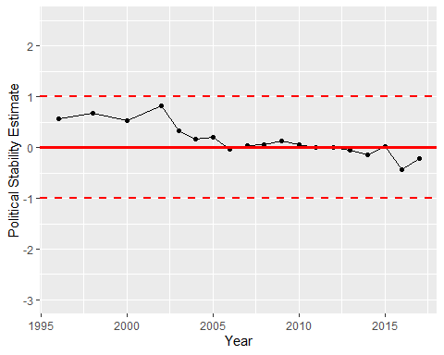

Political Stability Trend